Description | The SkyTower machine is a vulnerable Linux-based system designed for penetration testing practice. The assessment involved identifying web vulnerabilities, obtaining user access, and performing privilege escalation to gain root access.
Target IP | 192.168.0.109
Vulnerability Name | SQL Injection, Authentication Bypass, Exposed Credentials, Hidden SSH Service, Proxy Misconfiguration, and Privilege Escalation.
Service / Version | TCP / 80 HTTP  TCP / 3128 HTTP-Proxy Squid proxy
CVSS Score / Severity | 9.8 Critical
Attack Vector | CVSS:3.1/AV:N/AC:L/PR:N/UI:N/S:U/C:H/I:H/A:H
Proof of Concept | Step 1: Discover the IP of the target using Netdiscover  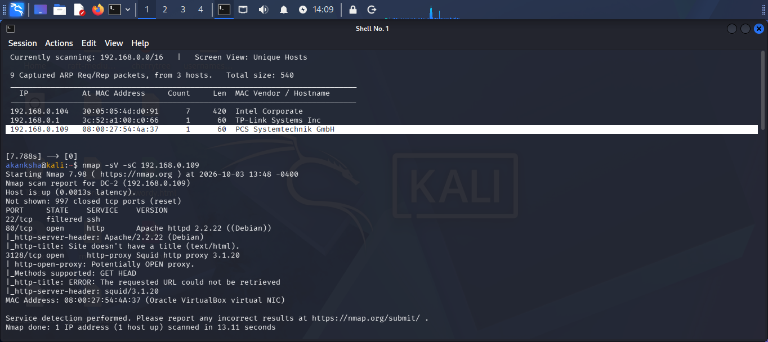  Step 2: Discover the open ports, Services on target machin.  Step 3: The Nmap scan identified port 80 (HTTP) and port 3128 (Squid Proxy) as open. I proceeded with further enumeration of the web service running on port 80.  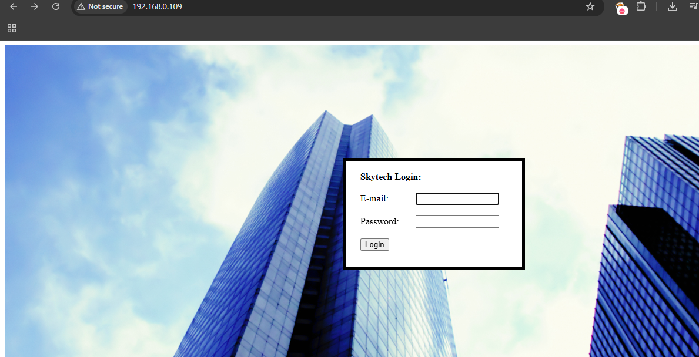  Step 4: I entered different SQL injection payloads in the password field, and the application revealed a SQL error, indicating possible SQL injection vulnerability. 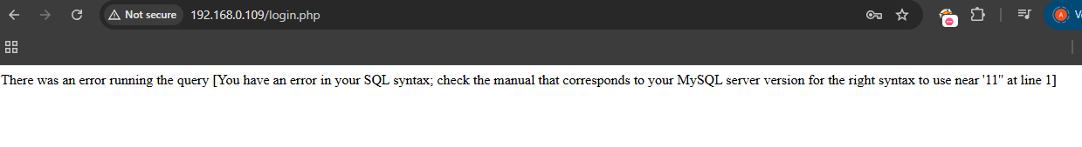  Step 5: I intercepted the login request using **Burp Suite** and tested the password parameter with the payload `' OR 1=1-- -` to verify the suspected SQL injection.  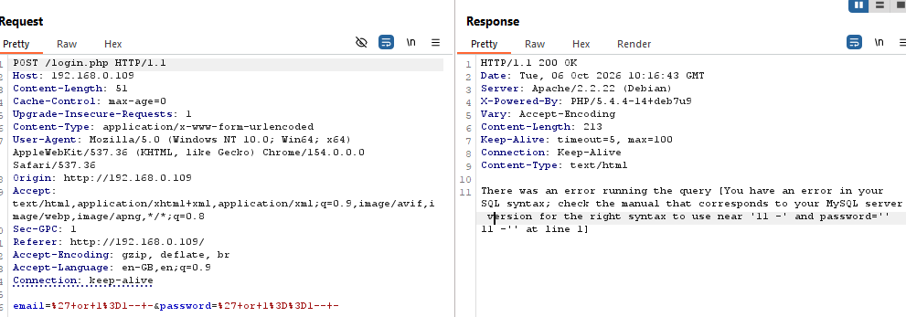  Step 6: The request and response were analyzed in Burp Suite to identify SQL injection filtering. The response indicated that keywords and characters such as OR, = and the termination sequence were being filtered.  Step 7: The SQL injection filter was bypassed by using an alternative SQL OR operator (||). This successfully bypassed the filtering mechanism and resulted in an authentication bypass.  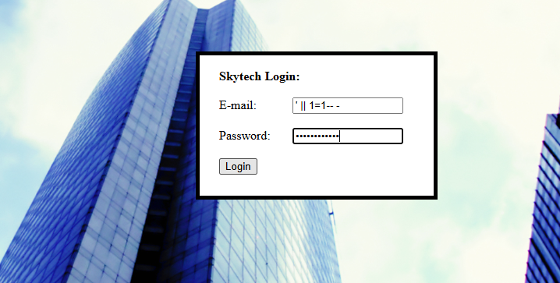  Step 8: After the authentication bypass, the application revealed a valid username and password for John, which were recorded for further testing.  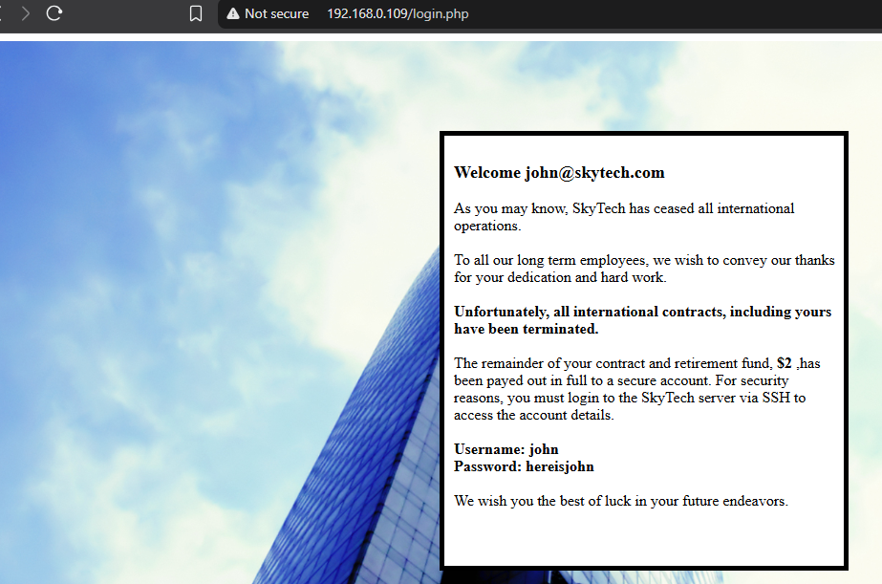  - Although SSH was not externally visible in the Nmap scan, further enumeration indicated that SSH was listening on the localhost interface.  Step 8: Squid proxy on port 3128 was used with ProxyTunnel to create a tunnel to the internal SSH service. This allowed SSH access through the proxy.  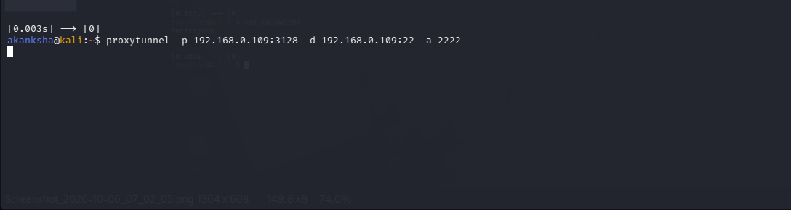  Step 9: Using the discovered John credentials through the proxy tunnel, SSH access to the SkyTower machine was successfully obtained.  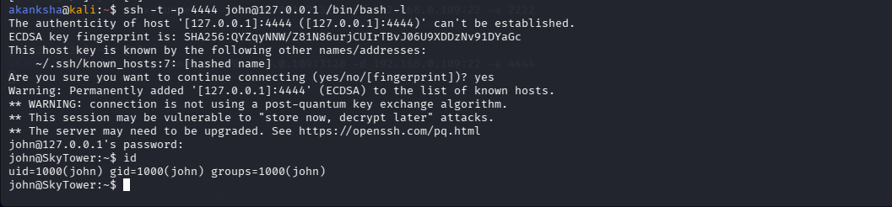  Step 10: Privilege-escalation When inspecting the login.php file, found some database credentials.  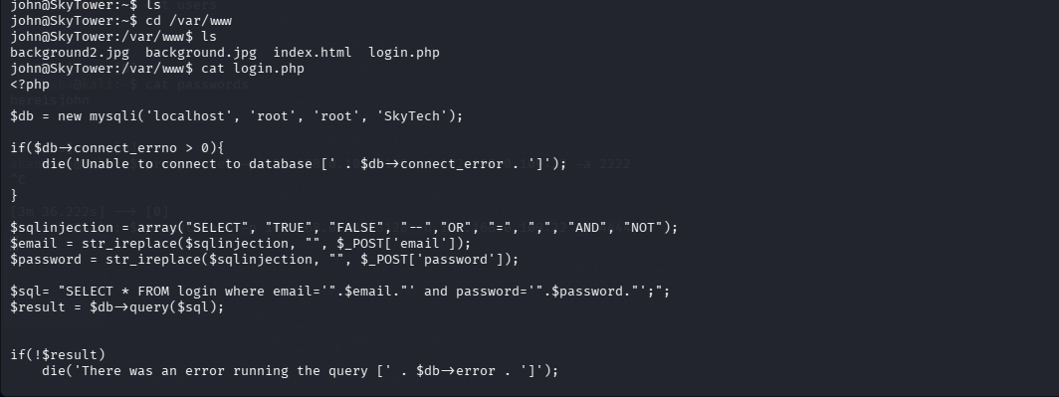  - Authenticating into MySQL  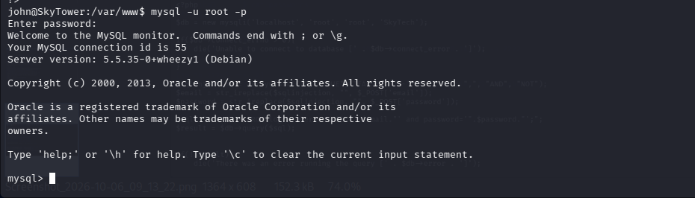  - Enumerate Database MySQL login to find other details  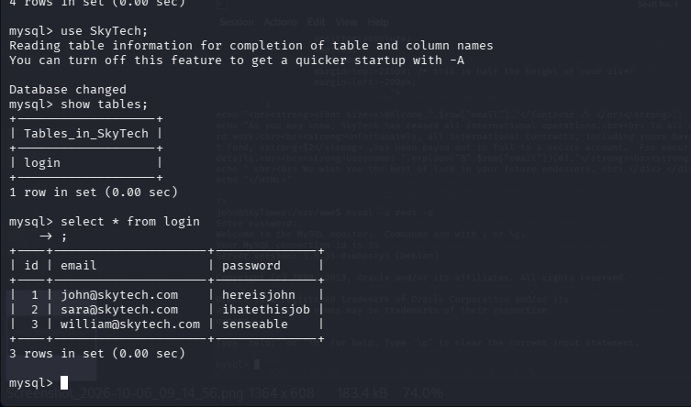  - We Got Credentials here  STEP 8: Switch user to sara using same method used for john.  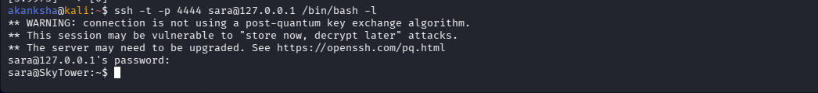  - Checking Privileges  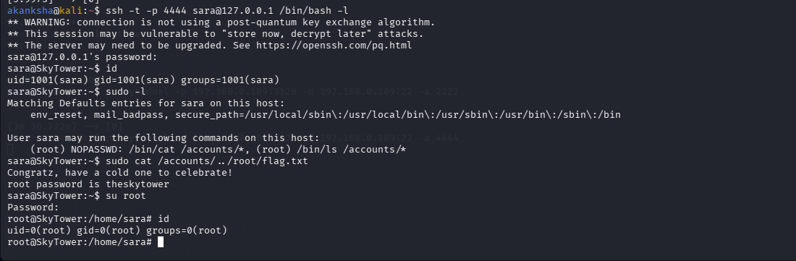  - We got root access
Impact | - Authentication bypass was possible through SQL injection.  - Valid user credentials were exposed.  - Internal SSH access was obtained.  - Privilege escalation was possible.  - Attacker could gain root-level access.  - Complete system compromise and unauthorized data access were possible.
Remediations | - Use prepared statements/parameterized queries to prevent SQL injection.  - Do not expose usernames or passwords in application responses.  - Restrict access to internal SSH services.  - Properly configure and secure the Squid proxy.  - Apply least-privilege permissions to users and sudo rules.  - Use strong and unique passwords.  - Regularly patch and update the operating system and services.
Reference | https://www.youtube.com/watch?v=3fxgnucsDY8&t=2784s

